

Department | FED
Subject | DSA-2
Academic Year | Ⅰ-Ⅲ Semester(2025-26)
Faculty Name | Ms. Alluri Swathi
Student Name | Anumola Jhansi Priya
Roll Number | 2520090205
Branch | CSIT
Course Outcome | 5
Case Study Topic: Digital Voting & Election Analytics System using Heap Sort

Work Done Summary:
Implemented Heap Sort in Java for election analytics and result reporting. Modeled candidates and their vote counts as records stored in an array. Heap Sort was used to organize candidates based on total votes received and generate ranked election results efficiently. Implemented voter registration, authentication verification, ballot casting, vote counting, election analytics, and fraud detection using sorting techniques. Demonstrated sorting of candidate vote counts to identify winners and generate election rankings. Compared Heap Sort with Bubble Sort – Heap Sort is more efficient for large election datasets due to its O(n log n) performance and in-place sorting capability

Implementation Details :
- Created Candidate class with fields: candidateId, candidateName, and voteCount.
- Stored candidate records in an array.
- Implemented heapify() function to maintain max-heap property.
- Built a max heap using candidate vote counts as keys.
- Performed Heap Sort to arrange candidates according to vote counts.
- Generated election rankings after sorting.
- Fraud detection performed by checking abnormal vote count entries before sorting.
- Main method inserted candidate data and demonstrated Heap Sort based election result analysis.

Result : Screenshots/Output

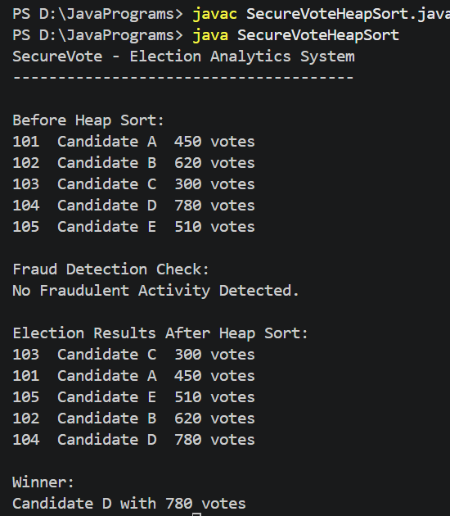

Time Complexity:

- Heap Construction: O(n)
- Heap Sort: O(n log n)
- Heap Sort efficiently ranks candidates and generates election reports for large-scale voting systems.

GitHub Link :
Student Signature | Faculty Signature

